Graded Project

**Cloud basics (Azure)**

Week 10

Table of Content

Context 3

Learning Outcome 3

Steps to be taken: 3

1. Create Virtual Machine 4

a) Region: East US 2 4

b) Instance: 1 (Ubuntu 18.04) 4

c) VM Size: D2s- V3 4

d) Storage: Standard HDD 4

2. Setup Apache and run default website 6

a) Open Port using Inbound Ports 6

b) Install Apache Server on VM using the script below in Bash Shell 6

c) Configure Default Website(index.html) 8

d) Change Text (“Azure Project – Great Learning”) on default Page 8

# **Context**

Creating web applications that are both resilient and scalable is an essential part of any application architecture. A well-designed application should scale seamlessly as demand increases and decreases, and be resilient enough to withstand the loss of one or more compute resources.

# Learning Outcome

* Deploy Virtual Machine Scale sets
* Set up a web server on a virtual machine

# Steps to be taken:

1) Create Virtual Machine

a) Region: East US 2

b) Instance: 1 (Ubuntu 18.04)

c) VM Size: D2s- V3

d) Storage: Standard HDD

*Note : The VM size and region given here is for reference only. You are free to change these*

*values as required.*

2) Setup Apache and run default website:

a) Open Port using Inbound Ports

b) Install Apache Server on VM using the script below in Bash Shell

c) Configure Default Website(index.html)

d) Change Text (“Azure Project – Great Learning”) on default Page

Script for installing Apache

*sudo apt-get update*

*sudo apt-get -y install apache2*

*sudo ufw allow 'Apache Full'*

*sudo systemctl start apache2.service*

*The file index.html is located in /var/www/html*

## Create Virtual Machine

### a) Region: East US 2

### b) Instance: 1 (Ubuntu 18.04)

### c) VM Size: D2s- V3

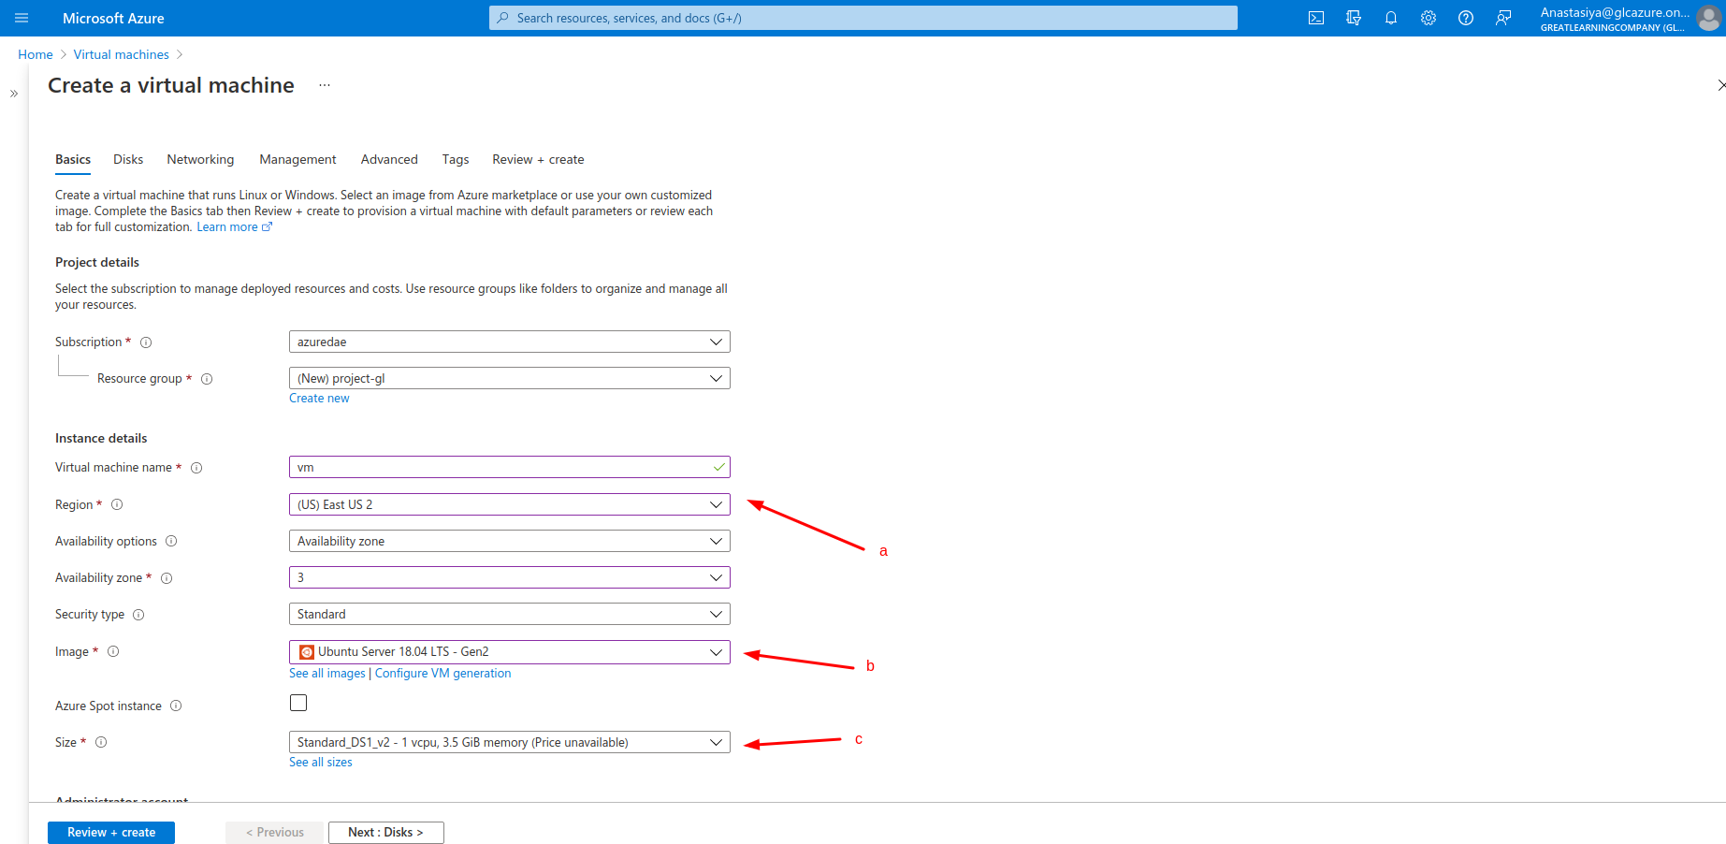

### d) Storage: Standard HDD

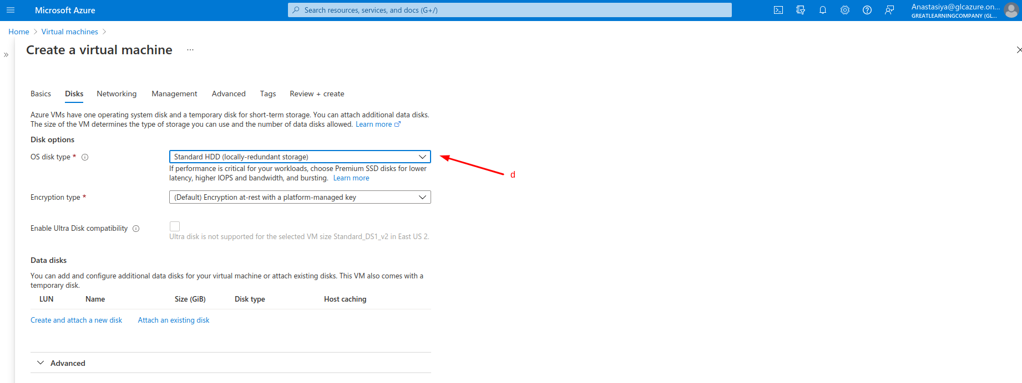

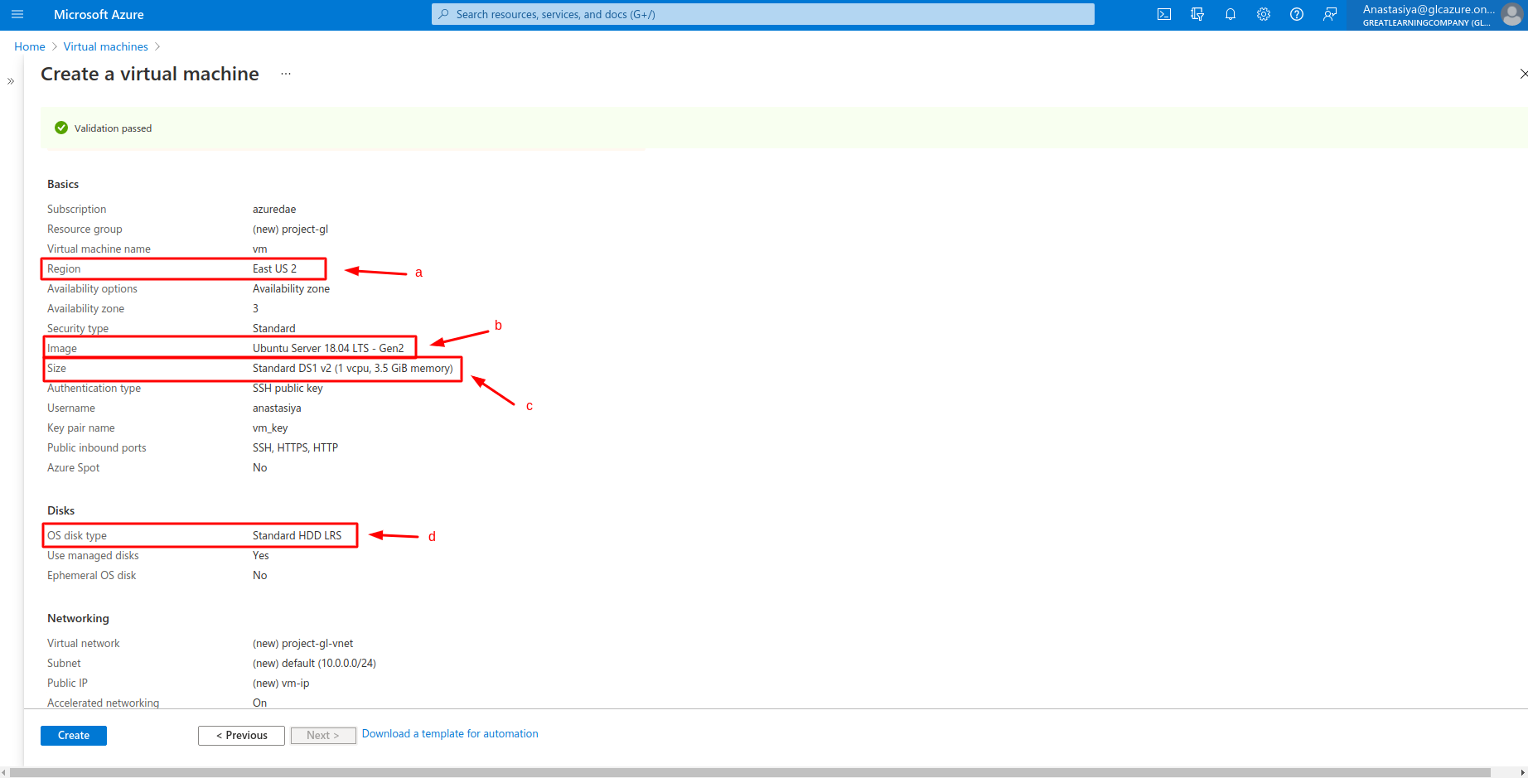

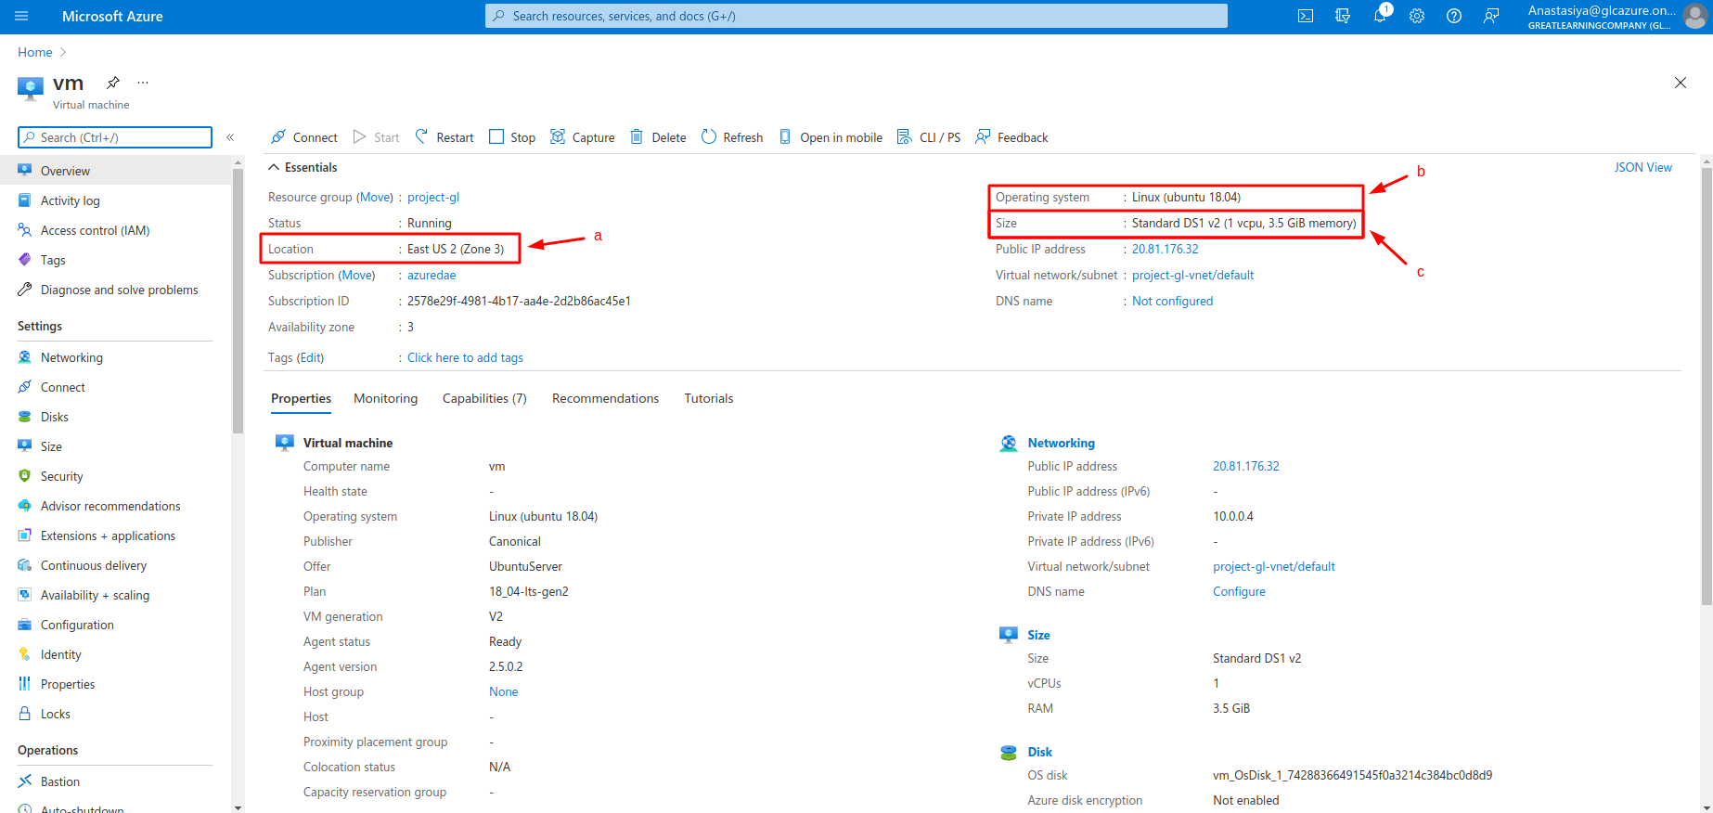

## 

## Setup Apache and run default website

### a) Open Port using Inbound Ports

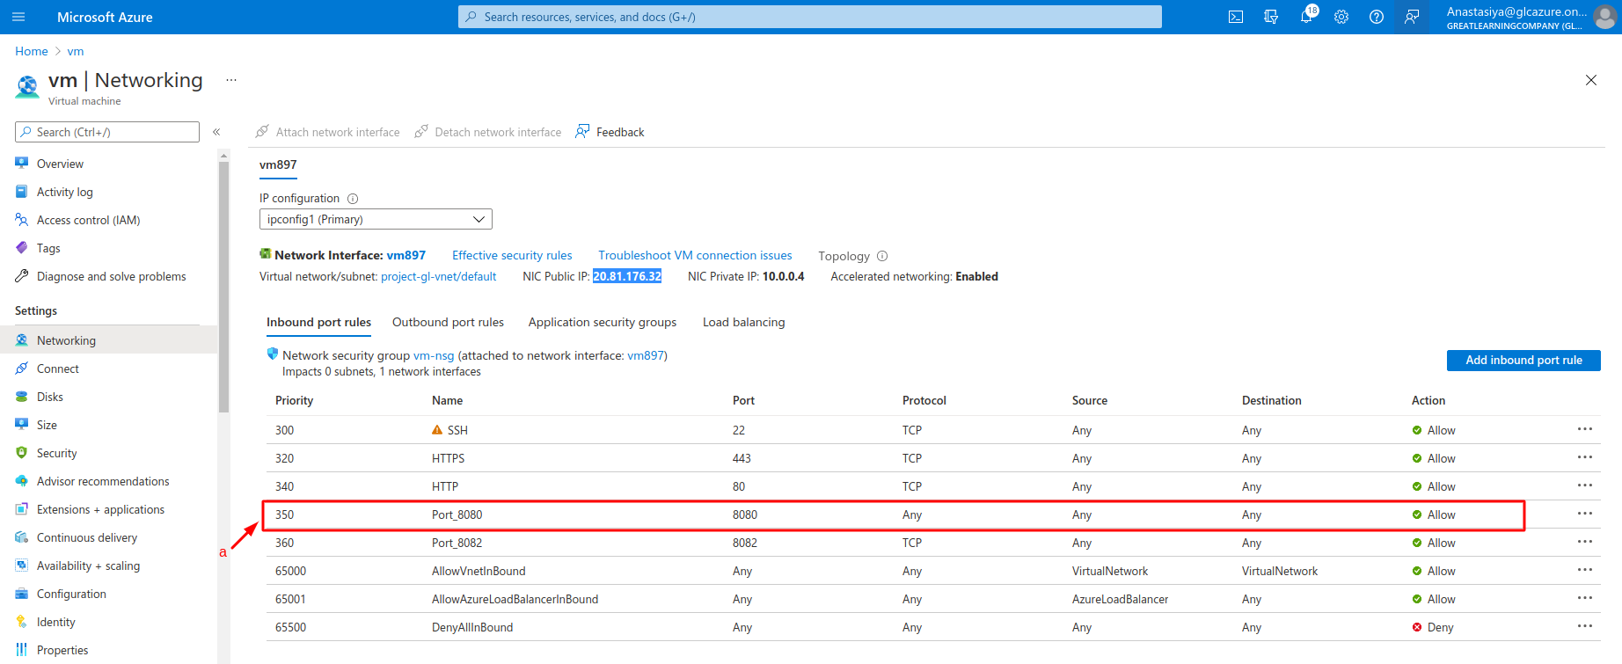

### b) Install Apache Server on VM using the script below in Bash Shell

For instalation Apache Server I have used Bastion

Checking my credentials for Bastion

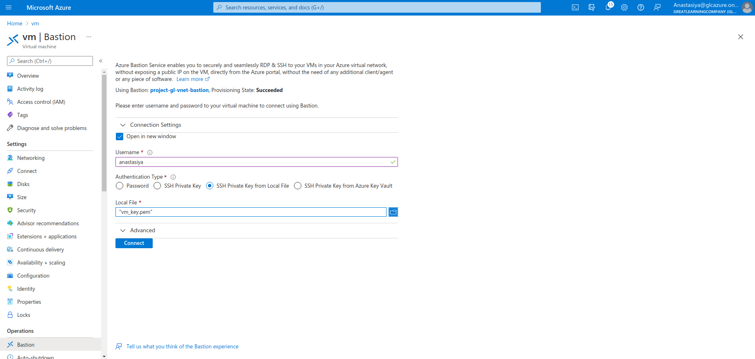

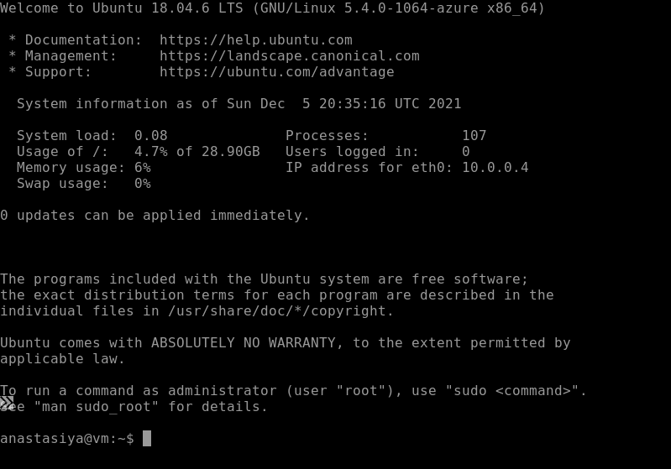Check Apache version on VM

### c) Configure Default Website(index.html)

Check file location

### d) Change Text (“Azure Project – Great Learning”) on default Page

For changing text I have used sudo nano comand

